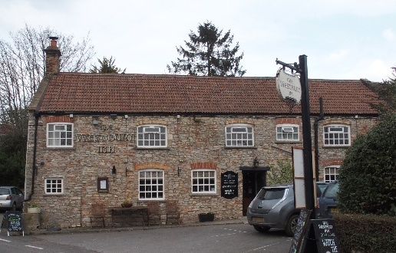

01749 870402
TAKEAWAY MENU Mon.-Sat.12-2pm & 5.30-7.30pm
***Menu for 27th April to 3rd May 2020 ***
Order day before advised but try last minute orders.
Self-collection via 10 minute time slots so only one person in pub at a time!
Delivery can be arranged for £2.50 Westbury, Easton, Rodney and Draycott. Cheddar £3.50. Over 70s, by arrangement, free.

STARTERS ****************************
Deep fried breaded brie with apple compote. £5.00
Fresh salmon and dill fishcakes with lemon mayo. £5.00
Lightly dusted calamari with sweet chilli dip. £5.00

MAINS ********************************
Beer battered cod, chips and peas. £10.00
Wholetail scampi, chips and peas. £10.00
Beef lasagne verde with garlic bread. £10.00
Braised lamb’s liver, bacon and onions with mash and veg. £10.00
Poached salmon with white wine, cream and coriander sauce with pots and veg. £12.50
Roasted red pepper, root vegetable & mozzarella bake with salad.£10.00
Chinese beef curry with rice and prawn crackers. £10.00
Chicken, ham and leek shortcrust pastry pie with pots and veg. £10.00
Fillet of pork medallions with pink peppercorn sauce with pots an veg. £12.50
Seafood pancake with cheese sauce, served with salad. £10.00
Ratatouille and stilton crumble with salad and garlic bread. £10.00

FRIDAY NIGHT ONLY
Slow cooked Moroccan style shoulder of lamb tagine with cous cous. £14.50
LIMITED - PRE-ORDERS ONLY PLEASE

For Puddings PTO

PUDDINGS ************************************ each £4.00

Chocolate brownie or Hot baked rum bananas or
Lemon cheesecake with mixed fruit compote or
Sticky toffee pudding or Warm Bakewell tart.

Sunday roasts from 12.00 ‘til 3.00pm! menu 5-7pm

SUNDAY TRADITIONAL ROASTS £12.50

Beef, lamb or pork
Poached salmon with white wine and cream coriander sauce.

BEER, CIDER, LAGER 4pts from £10.00

DELIVERY CHARGES
£2.50 to Westbury-sub-Mendip, Easton, Rodney Stoke
& Draycott
£3.50 to Cheddar

FREE DELIVERY to the over 70s
(also, for you, we can supply provisions and please don’t hesitate to call and speak to Andy or Ann-Marie to take your order)
01749 870402

