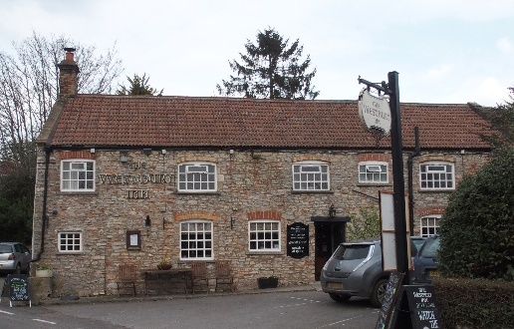

01749 870402
TAKEAWAY MENU Mon.-Sat.12-2pm & 5.30-7.30pm
***Menu for 20th April to 26th April 2020 ***
Order day before advised but try last minute orders.
Self-collection via 10 minute time slots so only one person in pub at a time!
Delivery can be arranged for £2.50 Westbury, Easton, Rodney and Draycott. Cheddar £3.50. Over 70s, by arrangement, free.
STARTERS ****************************
Vegetable pakora with curry mayo. £3.50
Light dusted whitebait with tartare sauce. £4.50
Breaded goat’s cheese with tomato salsa. £5.00
MAINS ********************************
Beer battered cod, chips and peas. £10.00
Wholetail scampi, chips and peas. £10.00
Cottage pie with fresh veg & crusty bread. £10.00
Oven baked salmon with lemon hollandaise, new pots & veg. £12.50
Vegetable lasagne with salad and garlic bread. £10.00
¼ slow roasted duck with orange gravy, potatoes & veg. £12.50
Chicken and broccoli gratin with salad & crusty bread £10.00
Somerset pork, gammon and cider casserole with pots & peas £10.00
Lamb Wellington with mint gravy with pots & veg £12.50
Sweet & sour king prawns Hong Kong style with rice & prawns crackers £12.50
Medallions of beef fillet with whisky cream sauce, veg & pots £14.50
Ratatouille fajitas with cottage cheese and salad £10.00

FRIDAY NIGHT ONLY
½ Roast chicken rotisserie with salad and chips £12.50
LIMITED PRE-ORDERS ONLY PLEASE

For Puddings PTO

PUDDINGS ************************************ each £4.00

Chocolate brownie or Hot baked rum bananas or
Lemon cheesecake with mixed fruit compote or
Sticky toffee pudding or Warm Bakewell tart.

Sunday roasts from 12.00 ‘til 3.00pm! menu 5-7pm

SUNDAY TRADITIONAL ROASTS £12.50

Beef, lamb or pork

BEER, CIDER, LAGER 4pts from £10.00

DELIVERY CHARGES
£2.50 to Westbury-sub-Mendip, Easton, Rodney Stoke
& Draycott
£3.50 to Cheddar

FREE DELIVERY to the over 70s
(also, for you, we can supply provisions and please don’t hesitate to call and speak to Andy or Ann-Marie to take your order)
01749 870402

