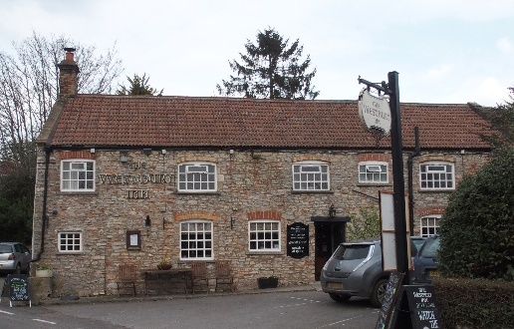

01749 870402
TAKEAWAY MENU Mon.-Sat.12-2pm & 5.30-7.30pm
***Menu for 13th April to 19th April 2020 ***
Order day before advised but try last minute orders.
Self-collection via 10 minute time slots so only one person in pub at a time!
Delivery can be arranged for £2.50 Westbury, Easton, Rodney and Draycott. Cheddar £3.50. Over 70s, by arrangement, free.

STARTERS ****************************
Tempura cauliflower florets with stilton mayo £4.00
Lightly dusted chiperoles (baby squid) with sweet chilli dip £4.50
Cajun chicken strips with Caesar dressing £5.00
MAINS ********************************
Beer battered cod, chips and peas £10.00
Wholetail scampi, chips and peas £10.00
Steak & red wine shortcrust pastry pie, pots & veg £10.00
Mild chicken korma with rice and poppadum £10.00
Chunky Fish pie with mash potato topping with crusty bread & peas £12.50
Chilli con carne with rice and cheesy nachos £10.00
Pulled pork, sausage and chestnut wellington with pots & veg £12.50
Chicken breast with brie, chorizo and garlic cream sauce with Pots & veg £12.50
Broccoli and mushroom chow Mein £10.00
Lamb and mint casserole with pots & veg £12.50
Pan fried gammon in parsley sauce with new pots & peas £10.00

PUDDINGS ************************************ each £4.00

Chocolate brownie
Hot baked rum bananas
Lemon cheesecake with mixed fruit compote
Sticky toffee pudding
Vanilla panna cotta with fruit coulis and shortbread
PTO

Sunday roasts from 12.00 ‘til 3.00pm! menu 5-7pm

SUNDAY TRADITIONAL ROASTS £12.50

Beef, lamb or pork

BEER, CIDER, LAGER 4pts from £10.00

DELIVERY CHARGES
£2.50 to Westbury-sub-Mendip, Easton, Rodney Stoke
& Draycott
£3.50 to Cheddar

FREE DELIVERY to the over 70s
(also, for you, we can supply provisions and please don’t hesitate to call and speak to Andy or Ann-Marie to take your order)
01749 870402

