Westbury Sub Mendip Community Shop Ltd  Green Lantern House, Stoke Road  Westbury Sub Mendip  WELLS  Somerset BA5 1HD  Tel: 01749 870296  westburysubmendipcommunityshop@gmail.com | 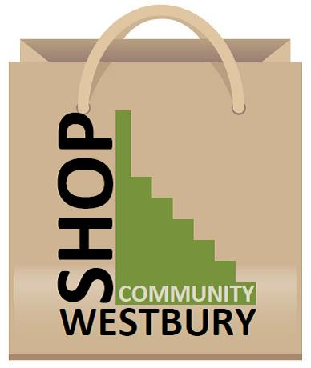

There are two levels of service available from the village shop.
If you are able to collect shopping yourself you can phone an order in advance and it will be kept for you in the shop. For this service you phone the existing number 01749 870296 You can pay on collection.
Remember however that in order to be sure of getting many fresh items we will need to give suppliers some notice. Current deadlines are below
- Bread – order by 2.00 pm for next day delivery
- Meat - order Tuesday morning for collection Thursday/Friday
- Cheese – please order by 5.00 pm Wednesday for Thursday pm
- Thorners – order by 5.00 pm Monday for Thursday pm
- Chew Valley Dairy -milk, butter, cream etc.- order before 5.00 pm for next day
Orders will be kept for you in the back room or the fridge and obviously are subject to availability.

A new service allows you to phone through an order and have it delivered to your doorstep by volunteers. You will be invoiced and need to settle up regularly by BACS or cheque – the volunteers delivering will not be handling cash. Users will need to open an account with the shop using the form below.
To use this service phone the new dedicated telephone line 07515 557209 You will need to leave your
- Name
- Address
- Contact phone number
- Your order

Westbury Sub Mendip Community Shop Ltd
Green Lantern House, Stoke Road
Westbury Sub Mendip
WELLS
Somerset BA5 1HD
Tel: 01749 870296
westburysubmendipcommunityshop@gmail.com

Shop Account for Self-Isolating Customers

Order line Number: 07515 557209
Email: westburyshoporders@gmail.com

Please pay single purchases exceeding £20 on the day of delivery. Smaller purchases will be invoiced weekly or monthly depending on the amount. Accounts to be settled by Bacs Transfer or cheque only. No cash payments please.

For Bacs Payments: Cooperative Bank Ltd
Sort Code: 09-92-99 Account Number: 65785247
Cheques payable to: Westbury sub Mendip Community Shop Ltd
***********************
Please open a Community shop account for me. I agree to pay invoices promptly.

Name: ……………………………………………………………Phone Number………………………..
Address:……………………………………………………………………………………………………………
Email:………………………………………………………………………………………………………………..

Signed: …………………………………………………… Date……………………………

