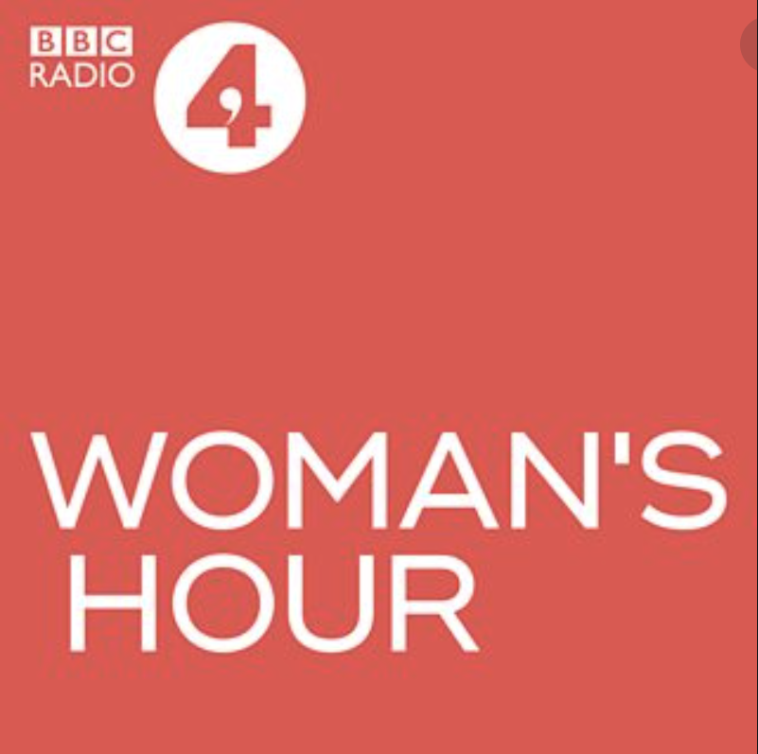

A Haiku inspired by Women’s Hour.

High Up, the Young Leaves
Obscure My View, Just Can’t See
As the Black Cap Trills.

Julie Romeo

