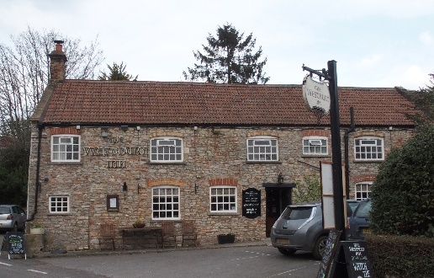

01749 870402
TAKEAWAY MENU Mon.-Sat.12-2pm & 5.30-7.30pm
***Menu for 30th March to 5th April 2020 ***
Order day before advised but try last minute orders.
Self-collection via 10 minute time slots so only one person in pub at a time!
Delivery can be arranged for £2.50. Over 70s, by arrangement, free.

Starters
Onion Bhaji with raita £3.50
Crispy squid with sweet chilli dip £5.00
Mains
Beer battered cod, chips and peas £10.00
Wholetail scampi, chips and peas £10.00
Steak and Guinness shortcrust pastry pie pots. veg. £10.00
Vegetable lasagne verde with garlic bread £10.00
Beef stew with dumplings, peas, carrots and crusty bread £10.00
Cauliflower and pepper penne pasta bake
topped with toasted almonds with garlic bread £10.00
Chicken tikka masala with rice and poppadum £10.00
Chicken and bacon sweet chilli flatbread with coleslaw £9.00
King prawn and smoked salmon linguini with garlic bread £12.50
Lamb Wellington, redcurrant gravy, pots. and veg. £12.50

Puddings £4.00
Chocolate brownie or Fruit crumble or Sticky toffee pudding or Apricot and whisky bread and butter pudding or hot baked rum bananas.

Sunday roasts from 12.00 ‘til 3.00pm! menu 5-7pm
SUNDAY TRADITIONAL ROASTS £12.50
Beef, lamb or pork

BEER, CIDER, LAGER 4pts from £10.00

