Our Noticeboards need refurbishing.
Can you help?
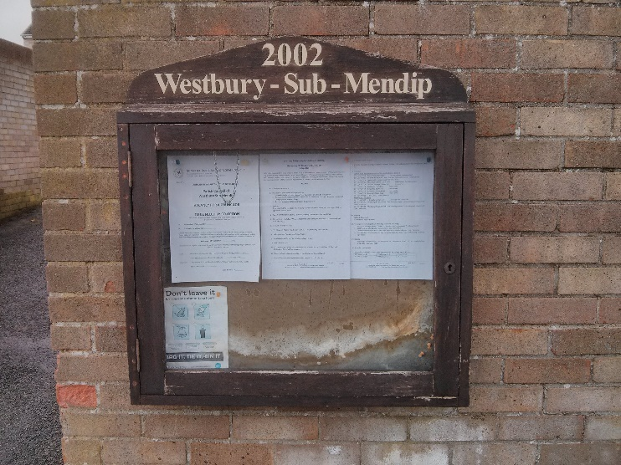  (at Stoneleigh) | 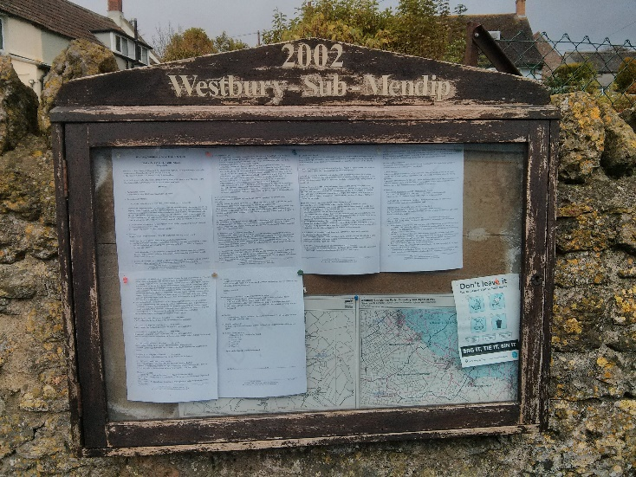  (at community shop garden wall)
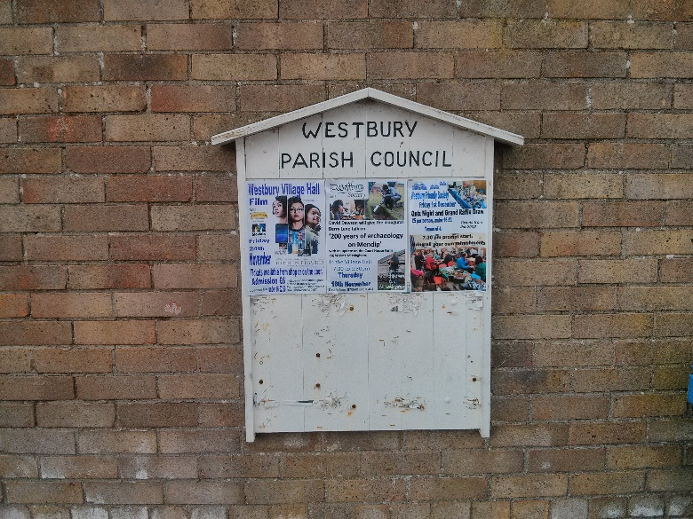  (at Stoneleigh) | 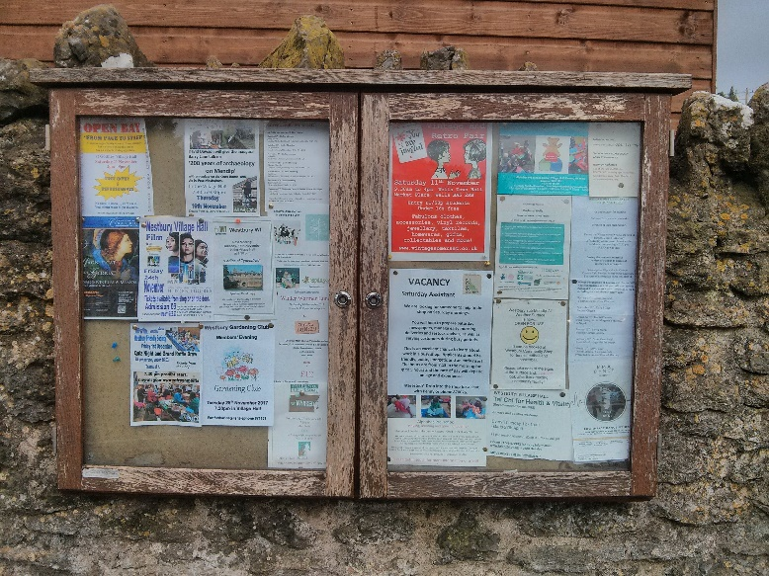  (at community shop garden wall)

Quotations invited, to the Clerk, Mark Smith, Orchardside, Mares Lane, Westbury Sub Mendip, Wells, Somerset BA5 1HX by 29th November 2017 please
Or tel. 01749 871076, email: clerk@westburysubmendip-pc.gov.uk for more information

