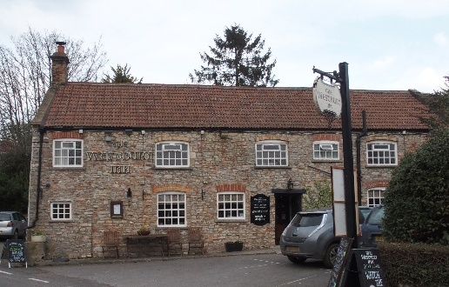
Dining Night

The next Dining Night in the Pub with
landlord Andy, and chef Sean, is on

Wednesday 21st February 2018 at 7.30pm.

Herewith the next menu with choices of main and dessert to make. Please let me know your choices of by Wednesday 14th February.

*************************************** ***********************************************

Main:

Hearty shin of beef stew with herb dumplings. A

Homemade chicken Kiev with parsley sauce. B
Vegetarian sausage 'toad in the hole'
with mushroom and red wine gravy. C

Served with a selection of fresh seasonal vegetables, garlic and herb mash and minted new potatoes

Dessert:

Homemade profiteroles filled with Chantilly cream topped with toffee sauce A

Steamed marmalade sponge pudding with custard B

Cost £16

************************************************************* ***********************************************************************

Tables of 4 – 8 will be arranged to fit the numbers coming so no one in left on their own.

Limits to numbers: In order not to overload the dining room, the kitchen and the serving people we need to restrict this to not many more than 40.

Please could you reply to me by the Wednesday 14th February.

If you want to join at the last minute, please telephone or e-mail me so that I can keep the numbers at no more than 40 and make sure that Andy has these numbers.

The next dining night is scheduled for Wednesday 14th March.

Peter Bright Wednesday 7th February.

